1. **Task Description:-**

The task was to build a web application using React.js, React Router, Node.js, Express, and JWT that demonstrates how to protect routes on both frontend and backend. The goal was to restrict access to certain pages and APIs so that only authenticated users can access them. The authentication is token-based using JWT (JSON Web Tokens).

1. **Task Output Screenshots:-**
   1. Home Page

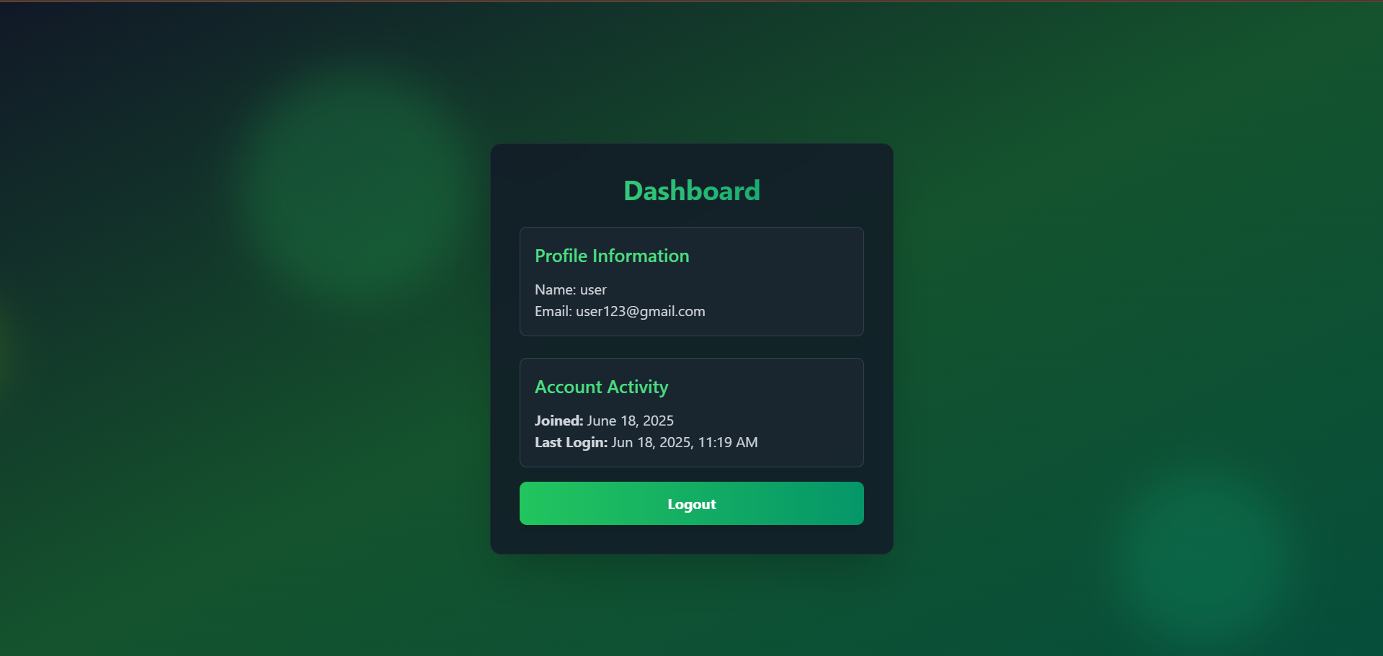

* 1. Signup Page

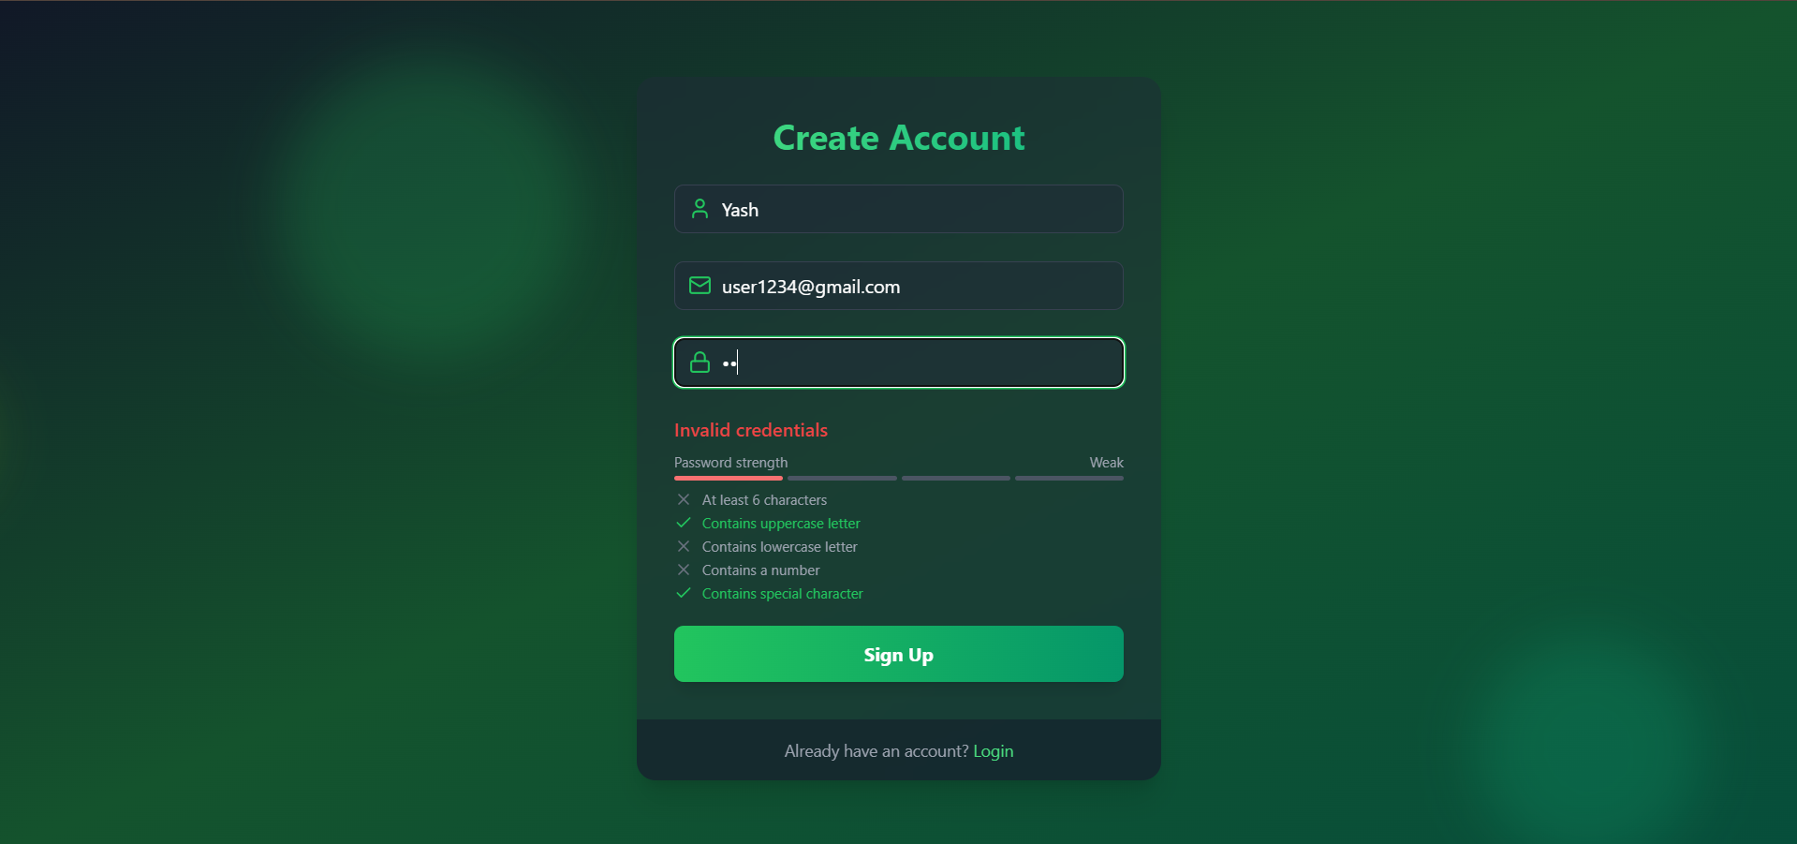

* 1. Login Page

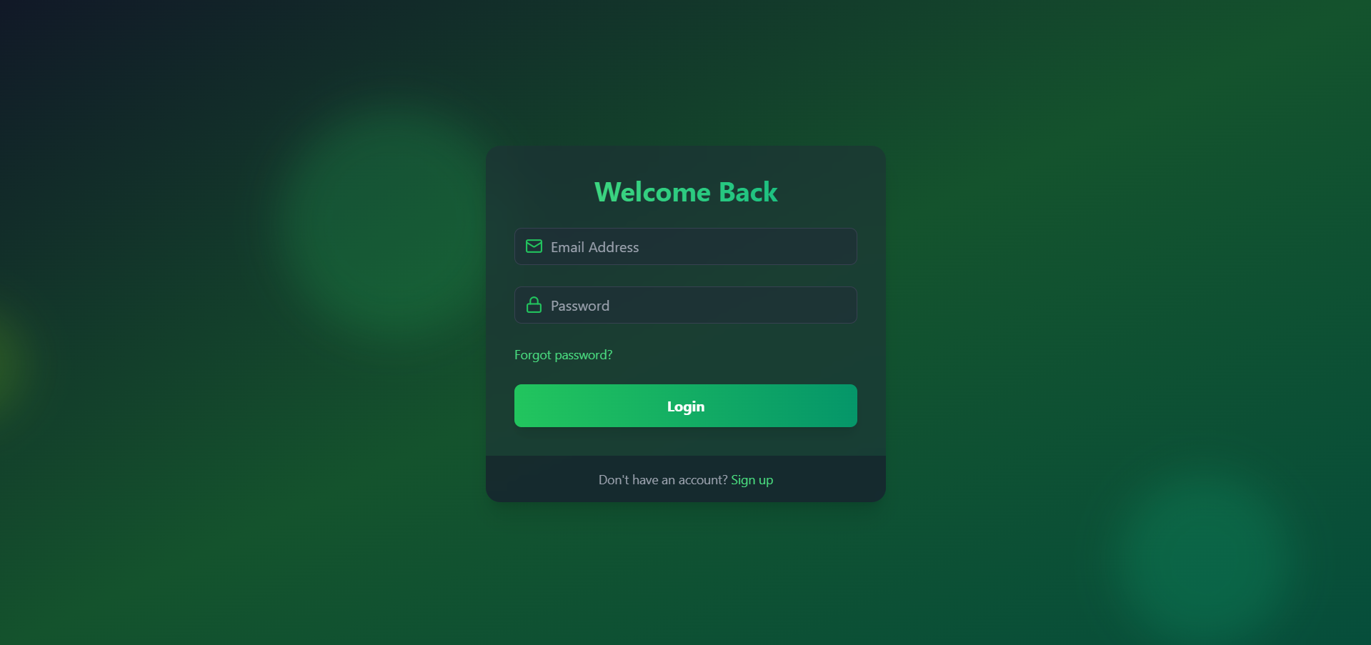

1. **Widget/Algorithm Used in Task:-**
   1. **JWT (jsonwebtoken in Node.js):** Used for signing tokens on login and verifying tokens in protected backend routes.
   2. **React Router DOM :** Used for routing between pages such as Home, Login, and Protected Dashboard.
   3. **Bcryptjs :** Used to hash and compare passwords securely on the backend.
   4. A middleware function verifyToken was created to check the Authorization header, decode and validate the JWT, and allow or deny access accordingly.
   5. Tokens were set to expire after a certain duration (e.g.,7 Days) for enhanced security.
   6. Every time when it refresh it check for the token. If it is invalid or token is expire then it will send the user to the Login page